

**Faculty of engineering - Shoubra**

**Benha University**

**Research Article / Research Project / Literature Review**

in fulfillment of the requirements of

|  |  |
| --- | --- |
| **Department** | **Engineering Mathematics and Physics** |
| **Division** | **-----------------** |
| **Academic Year** | **2019-2020 Preparatory** |
| **Course name** | **Computer** |
| **Course code** | **ECE001** |

**Title: -**

# Internet of Things

By:

|  |  |  |  |
| --- | --- | --- | --- |
|  | Name | Edu mail | B.N |
| 1 | Nasr mohamed Nasr | nasr196122@feng.bu.edu.eg | 996 |

**Approved by:**

|  |  |
| --- | --- |
| Examiners committee | Signature |
| **Dr.Ahmed Bayoumi** |  |
| **Dr.Shady Elmashad** |  |
| **Dr. Abdelhamid Attaby** |  |
|  |  |
|  |  |

# Internet of Things

1-First page introduction:

**A-Source code**

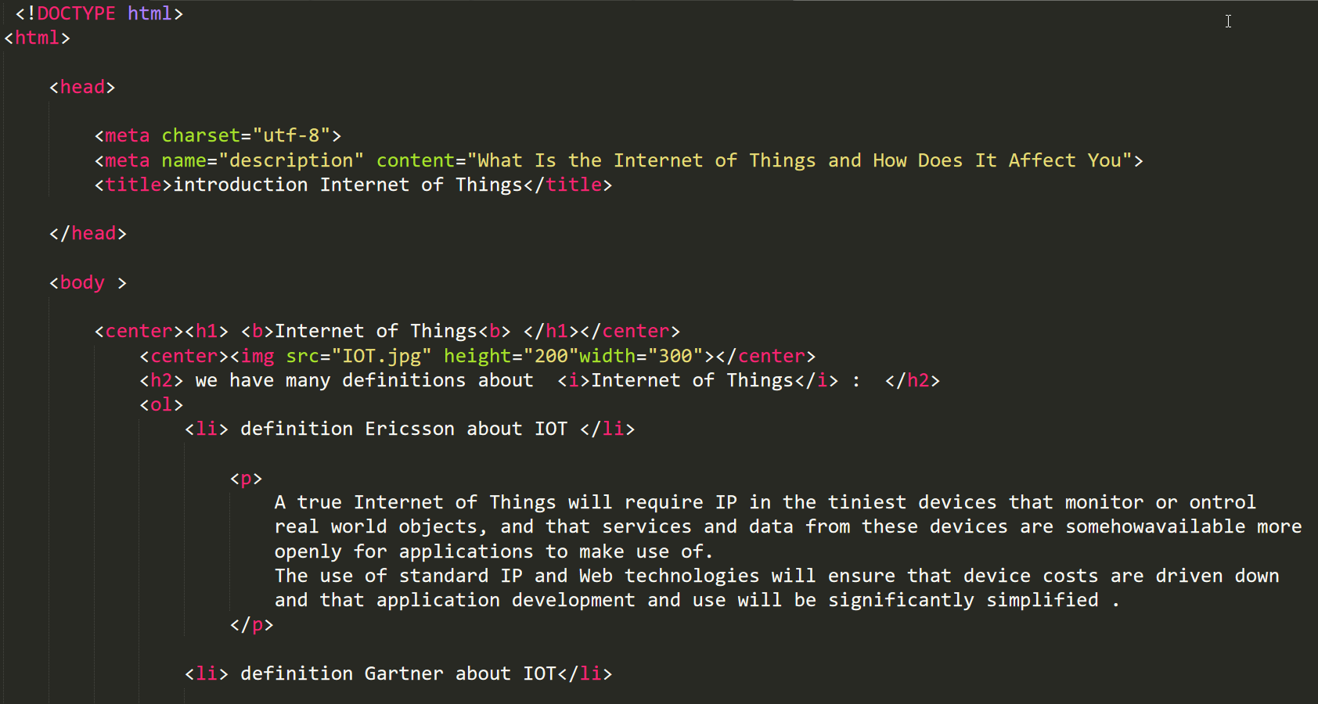

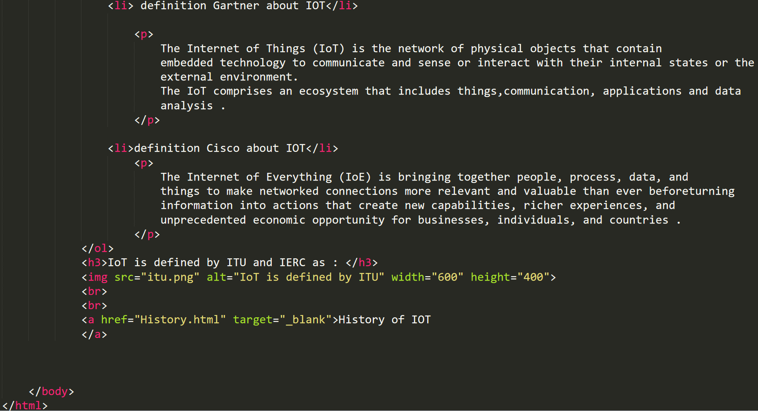

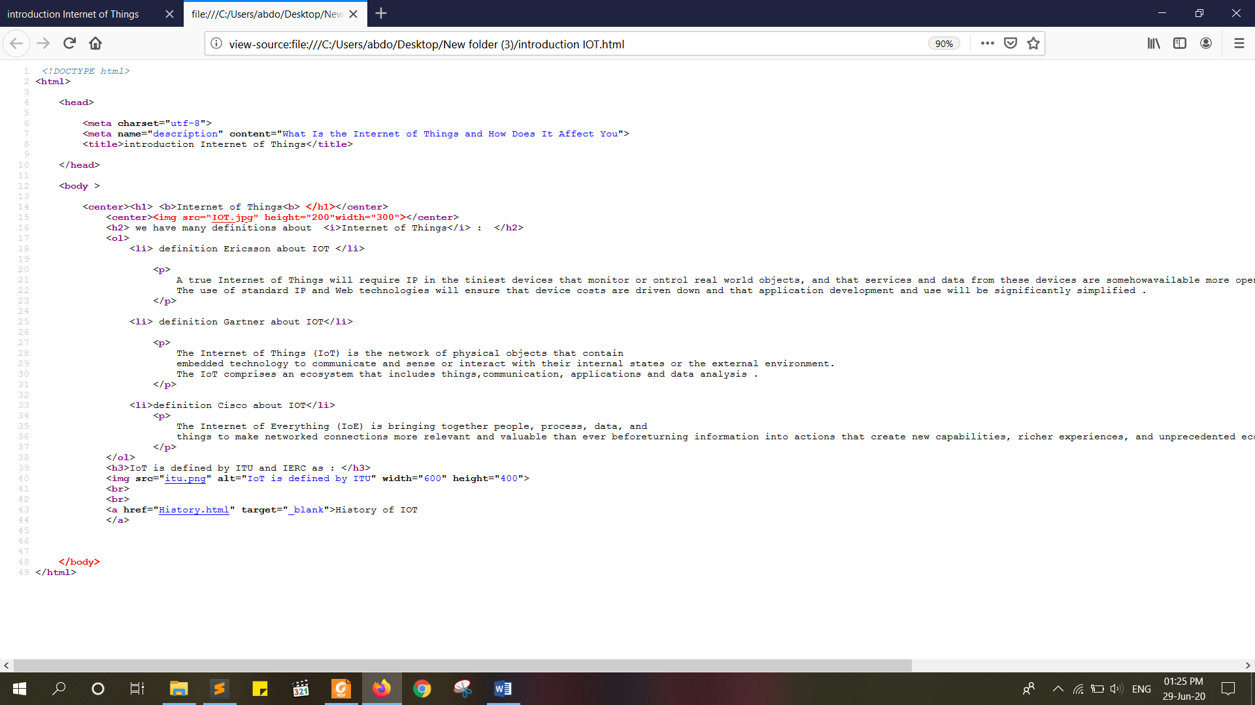**Code in website**

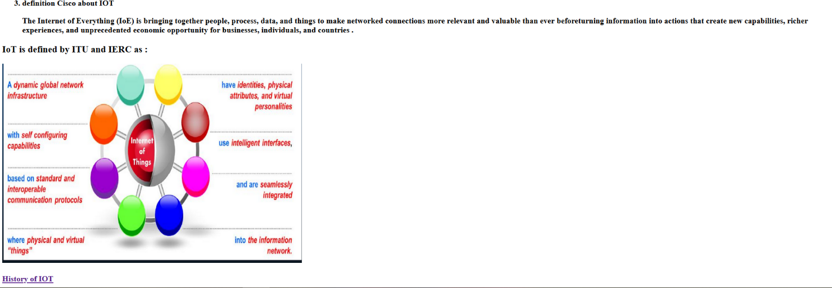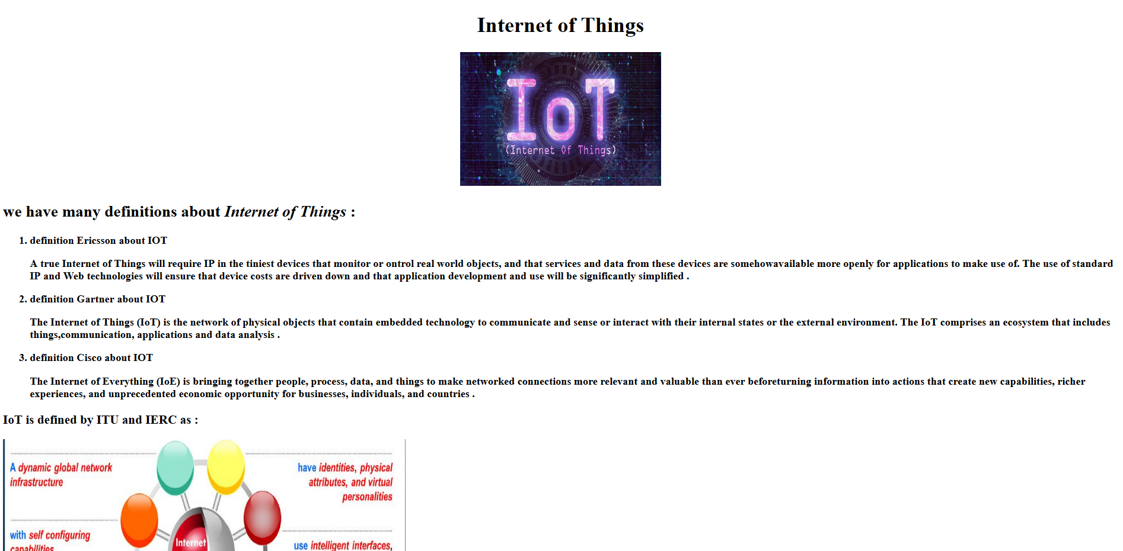**B- the page**

# 2-second page History of Internet Of Things:

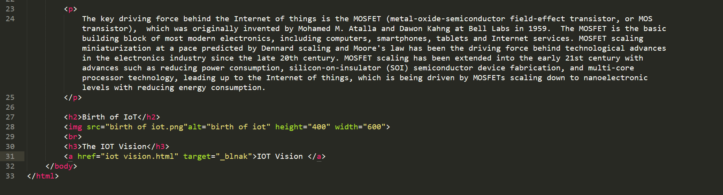**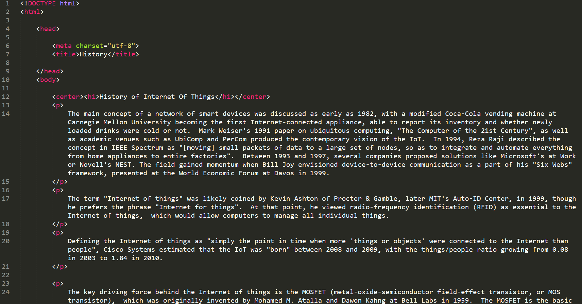A-Source code**

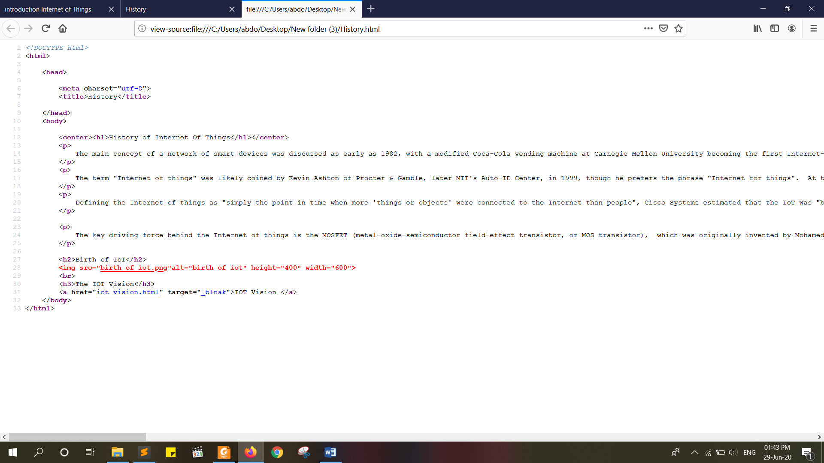**Code in website**

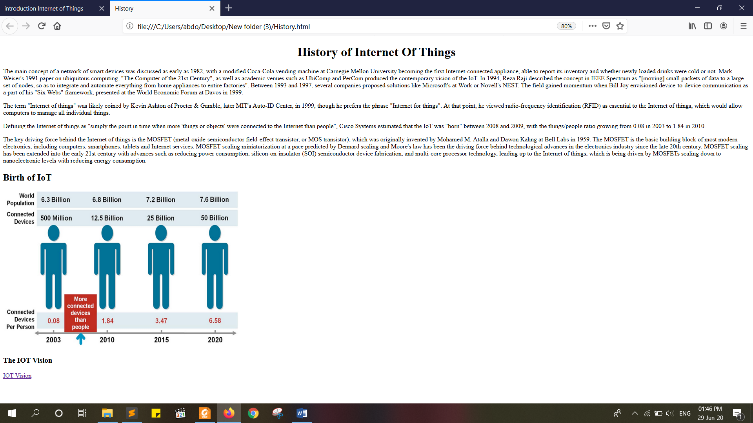**B- the page**

# 3-third page IOT vision :

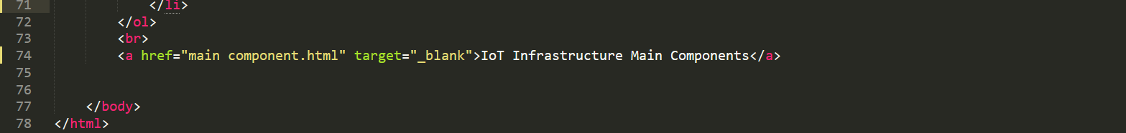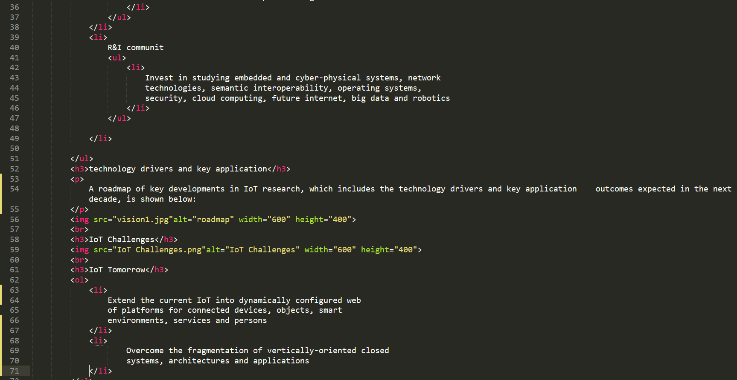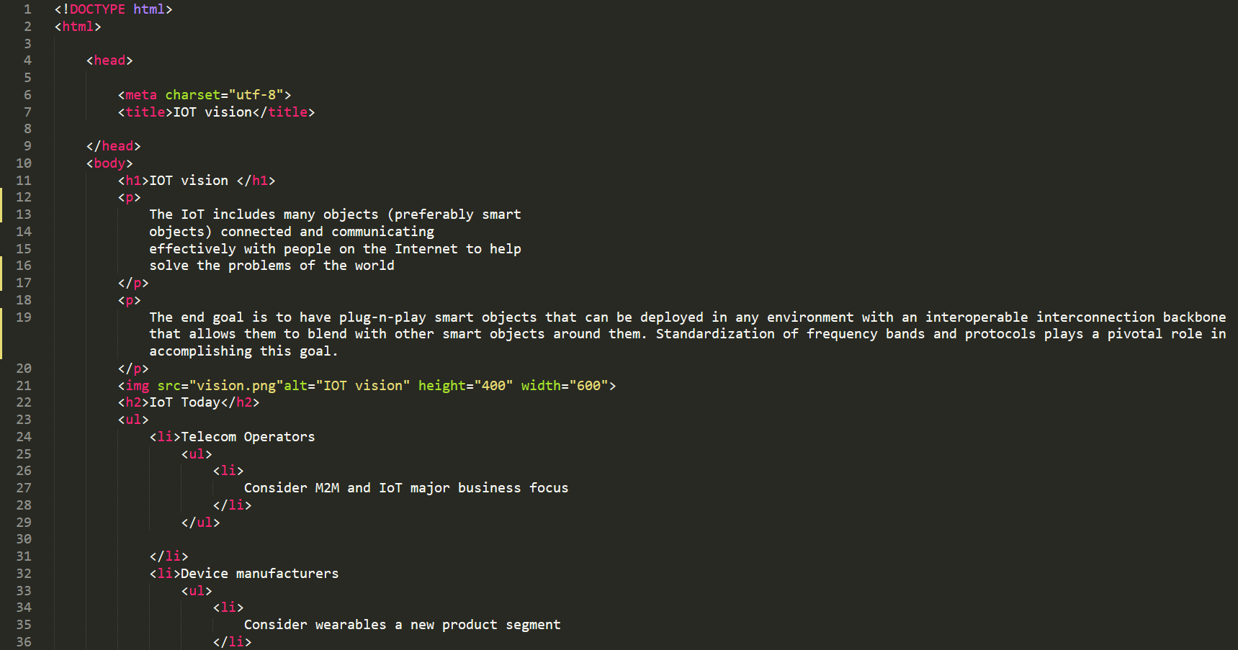**A-Source code**

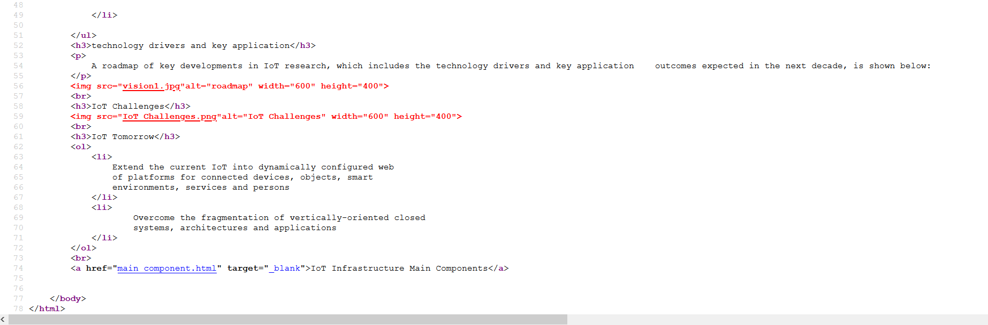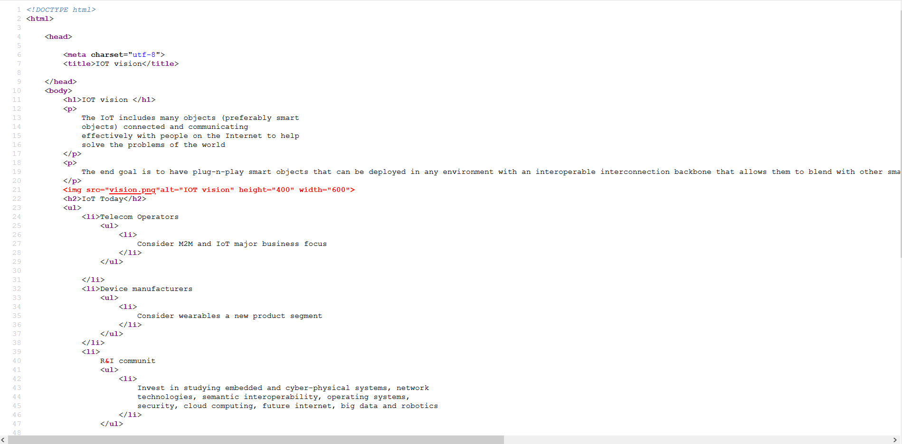**Code in website**

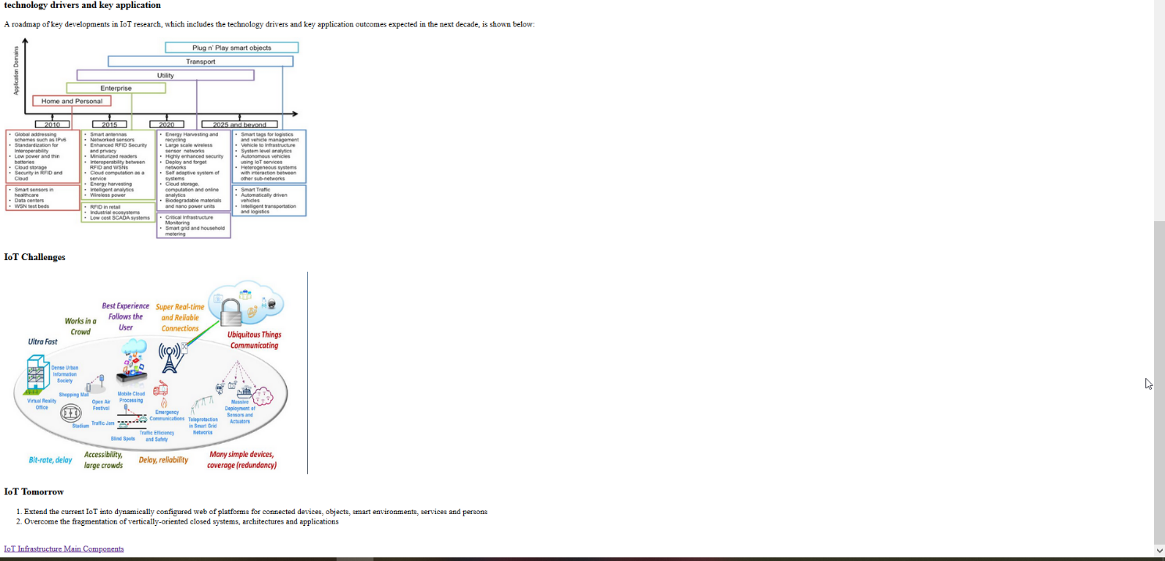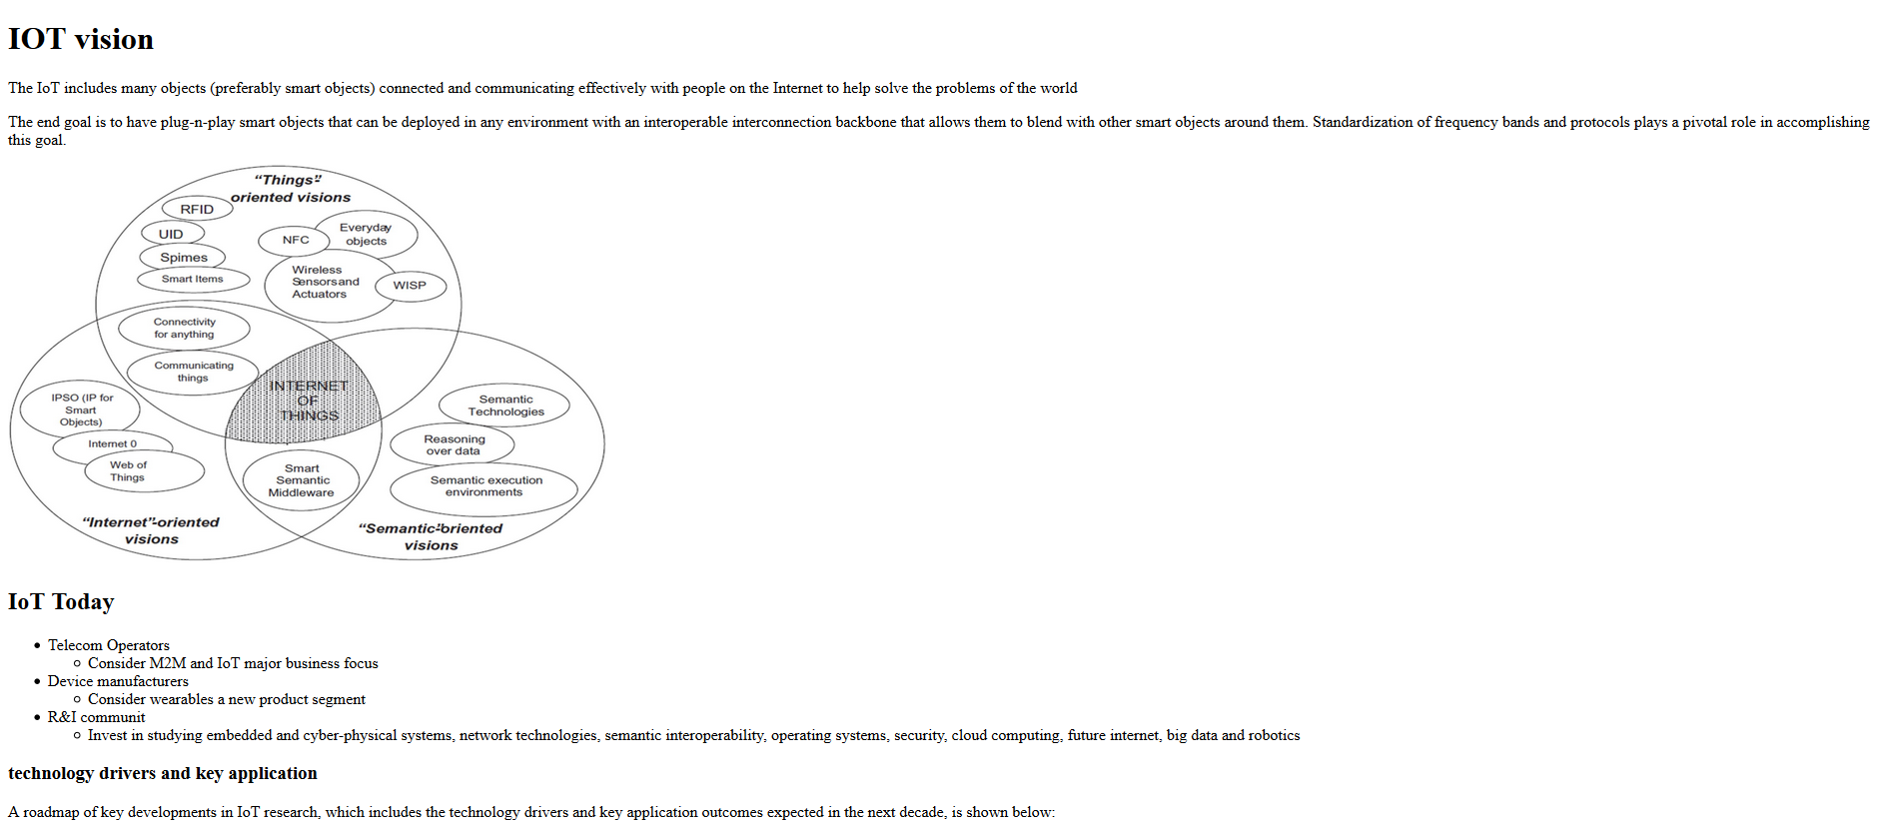**B- the page**

# 4-fourth page IoT Infrastructure Main Components:

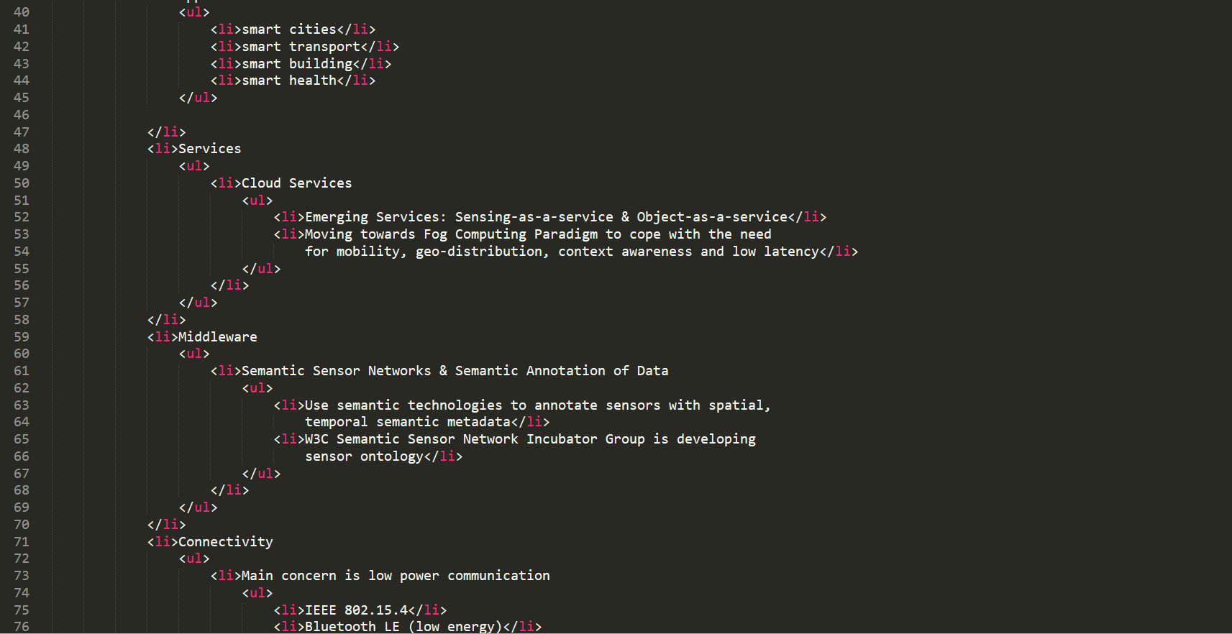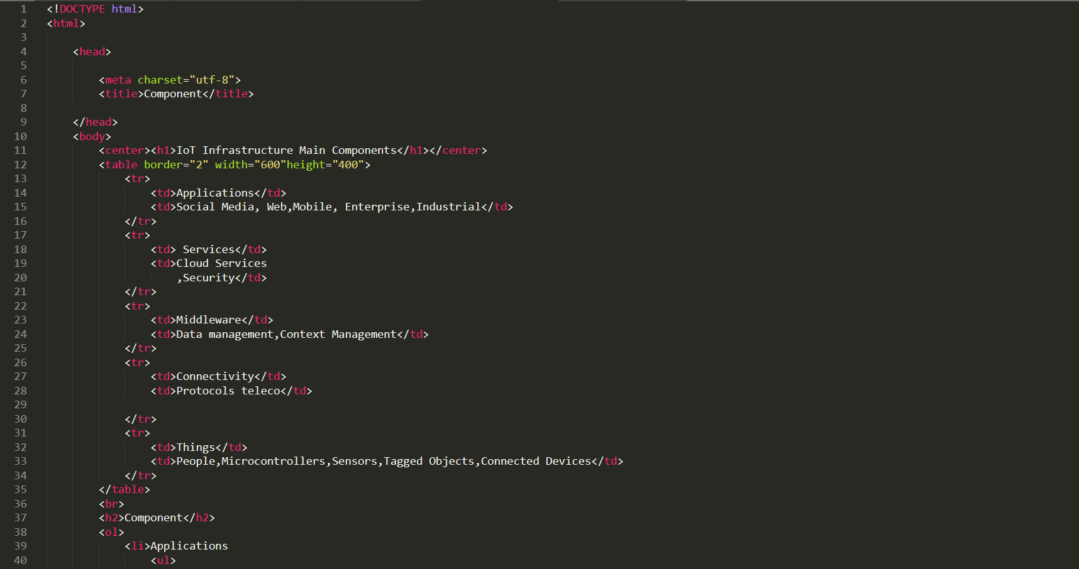**A-Source code**

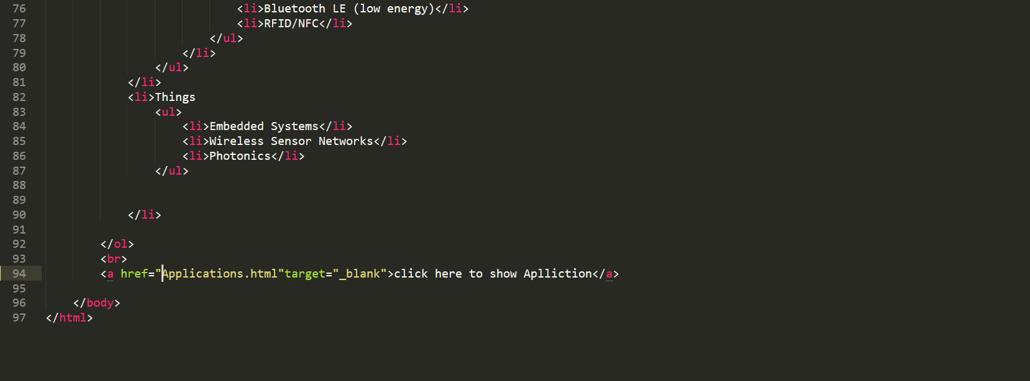

**code in website**

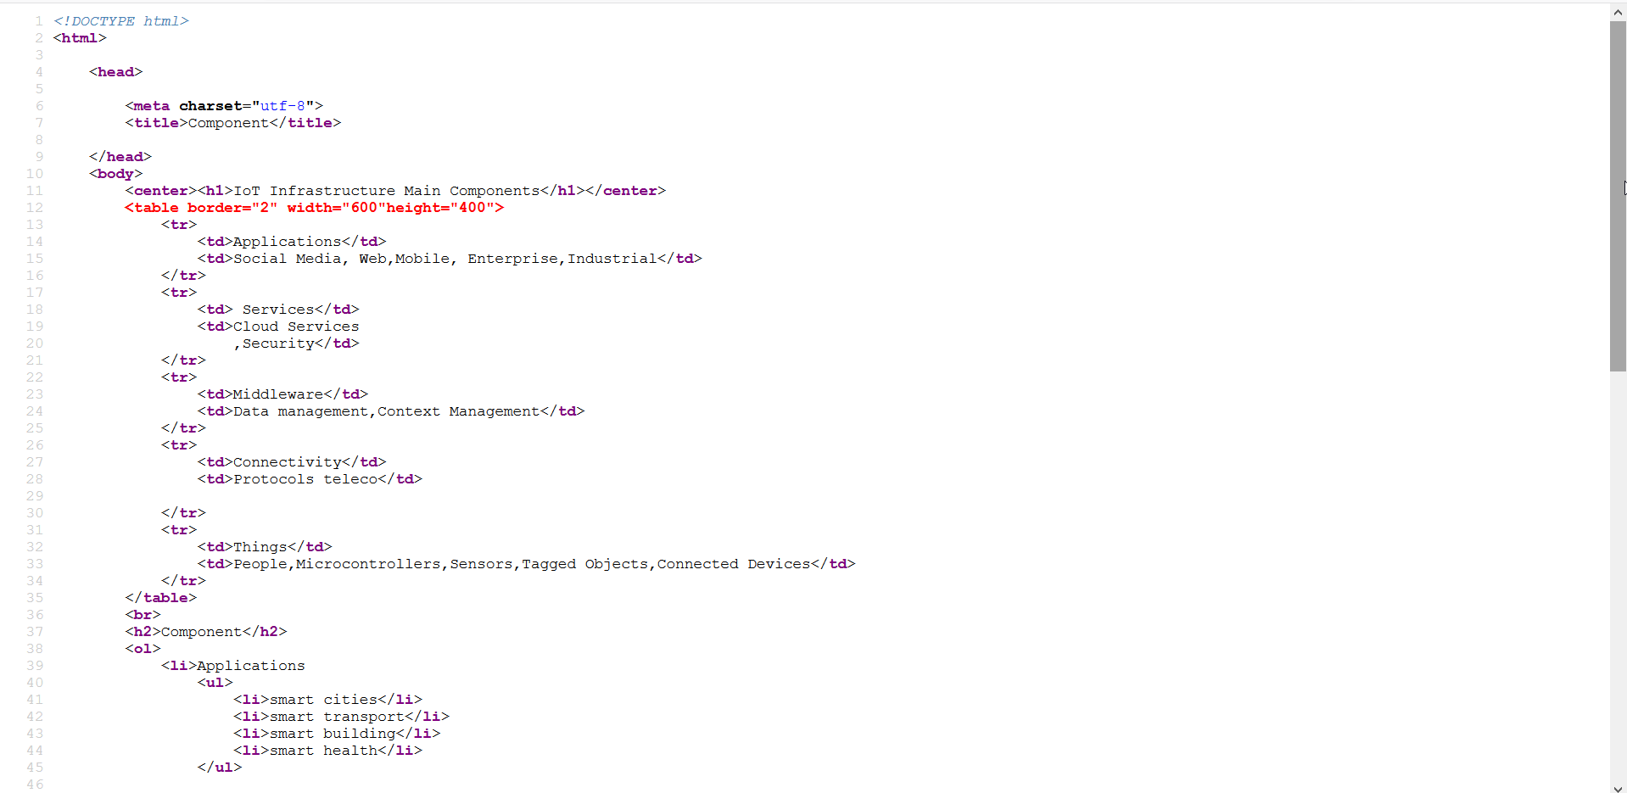

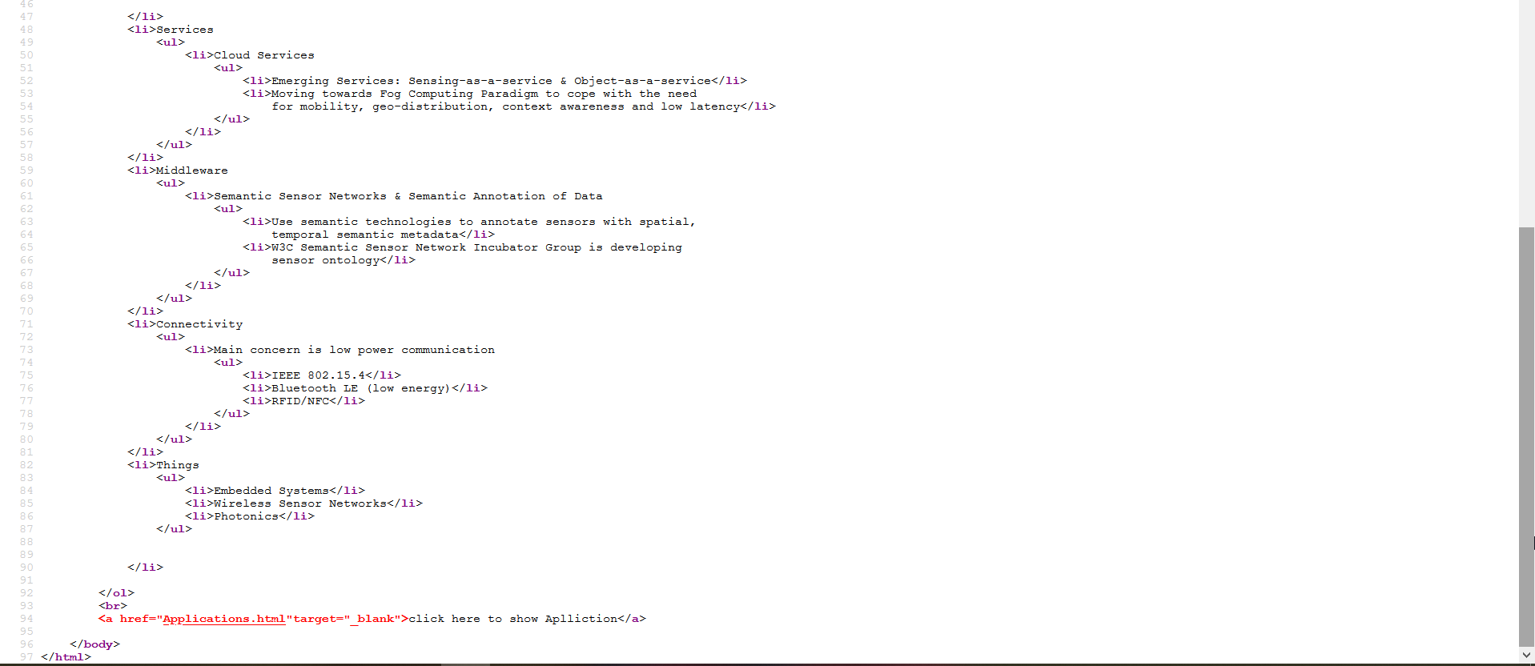

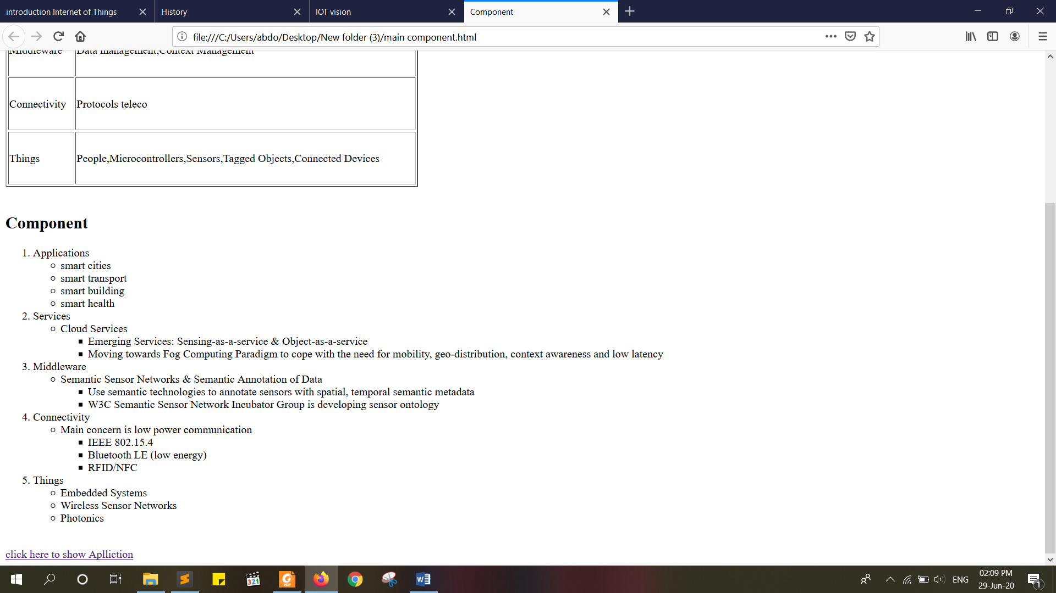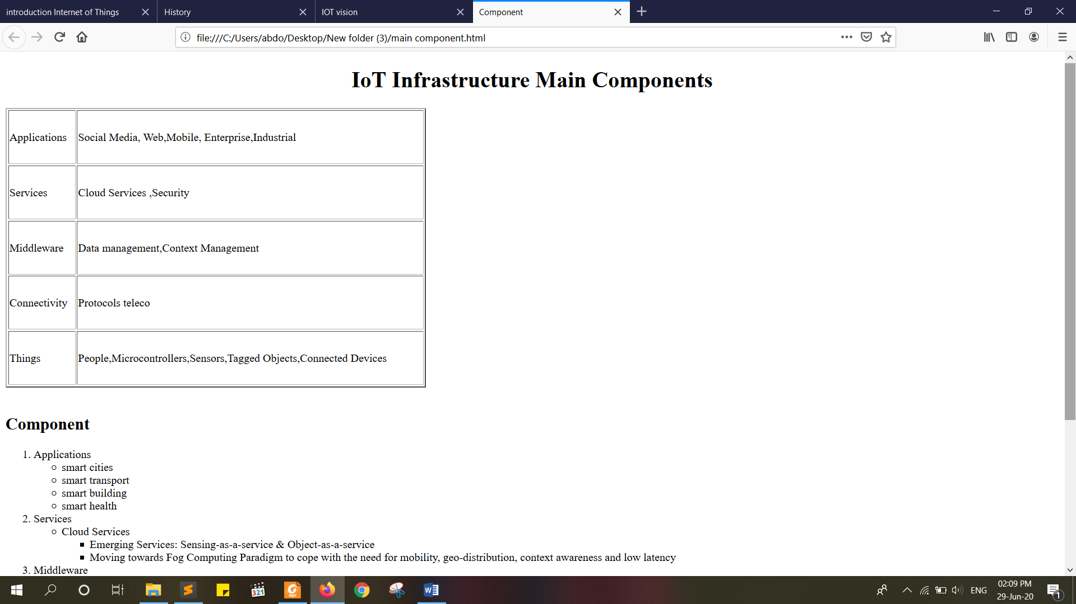**B- the page**

# 5-fifth page IoT Applications:

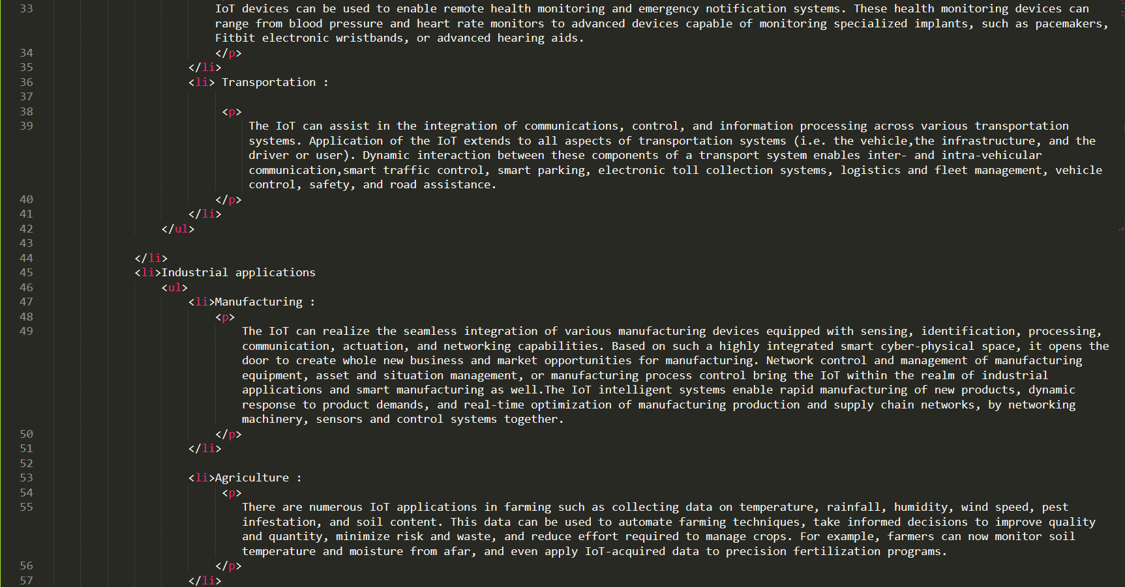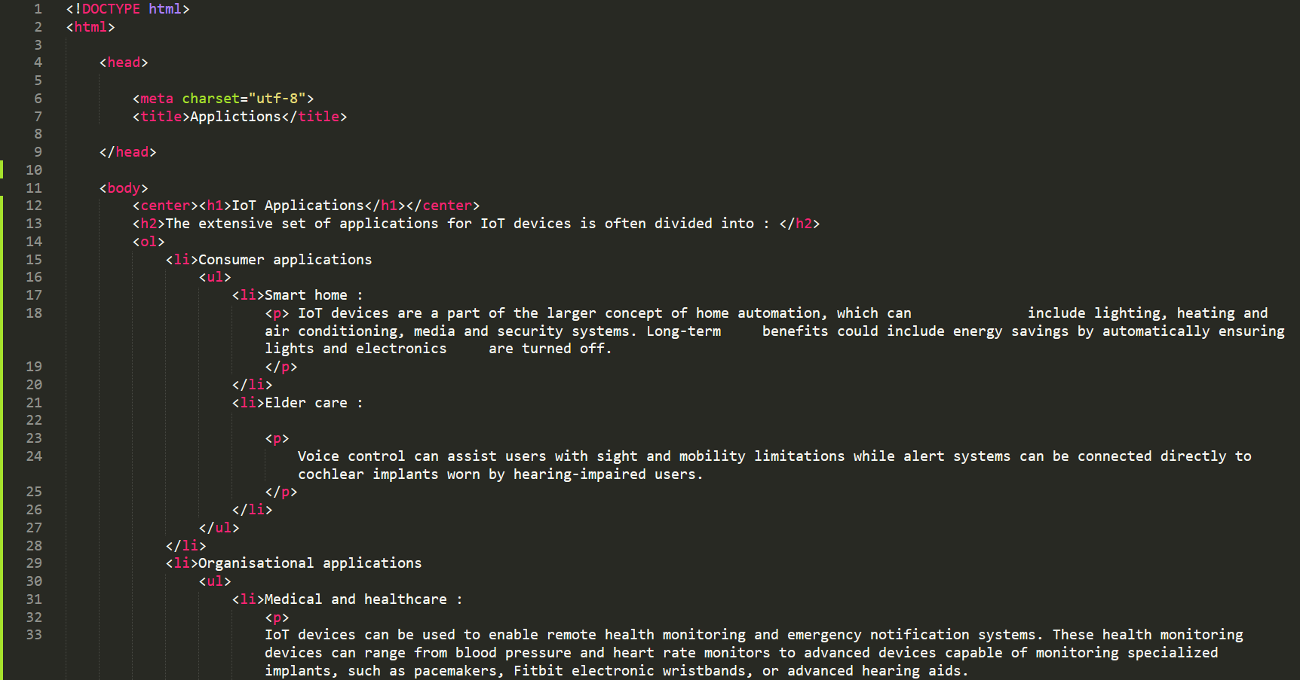**A-Source code**

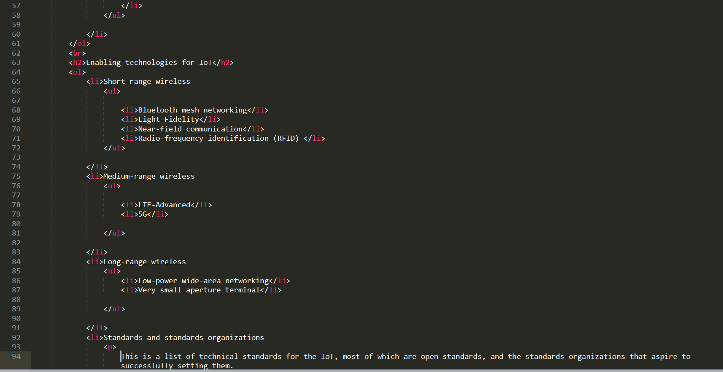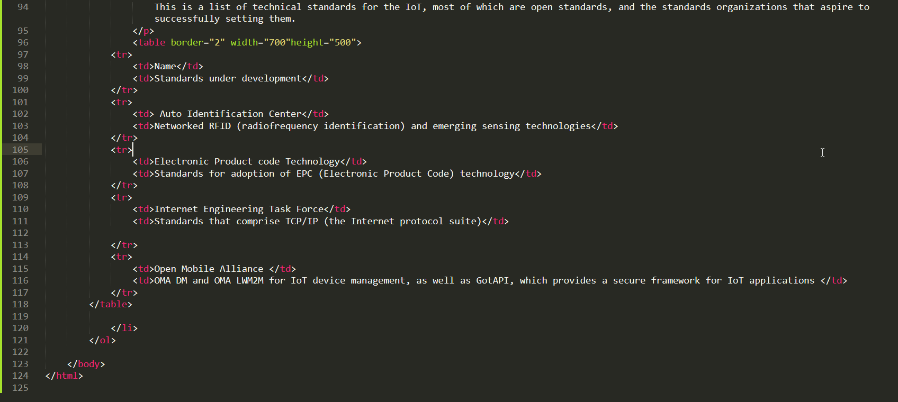

**code in website**

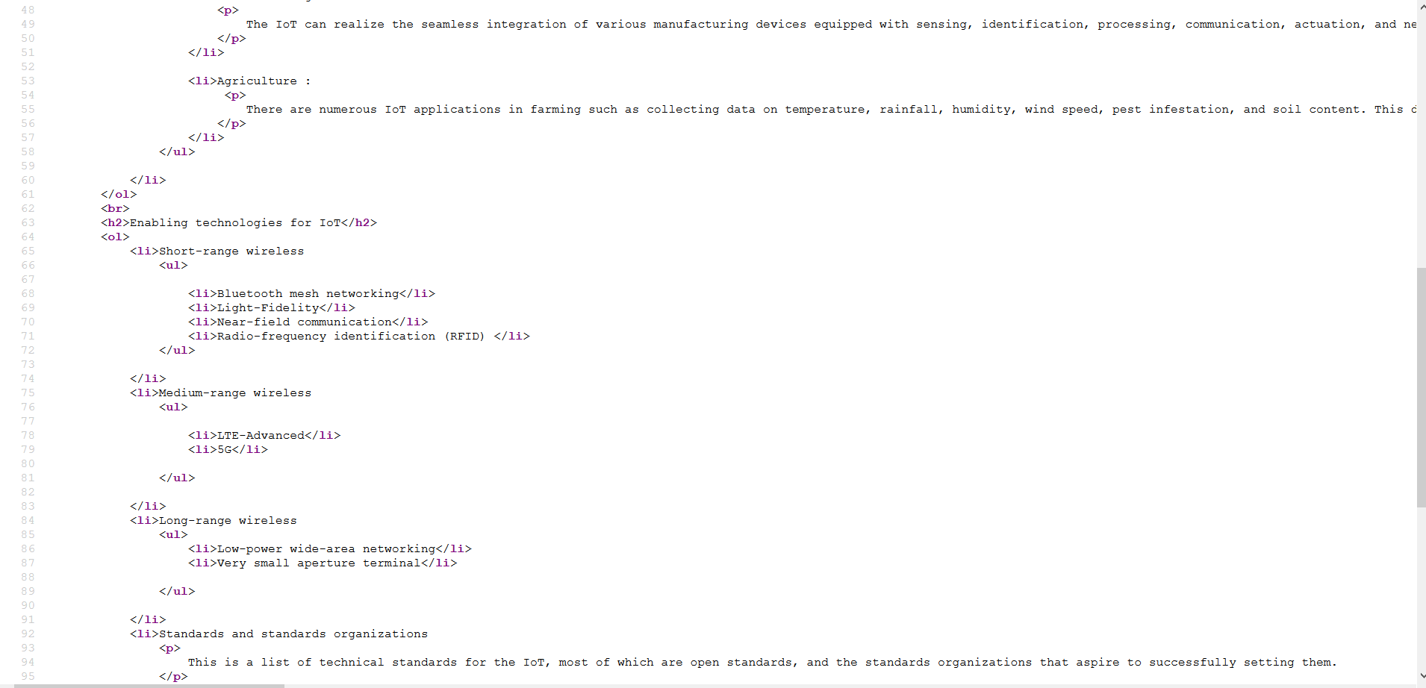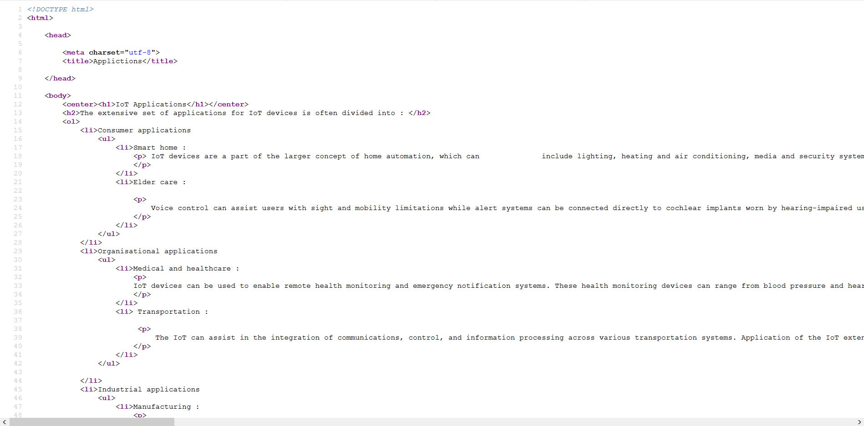

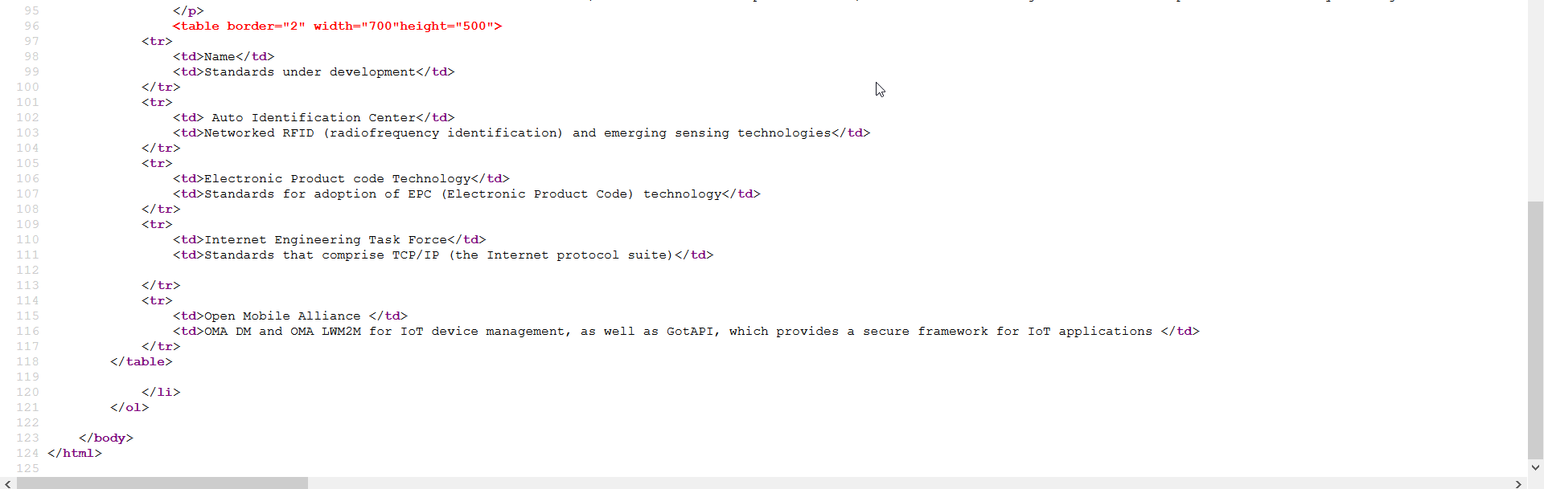

**B- the page**



